SPRING Multi-Spectral Retinal Imager -Product Design Specifications
- General Characteristics:
  - Slit Lamp Add-on: Mounted on Pin& Rail with lock option, next to Slit-lamp device in physician’s examination room/ lane – the device should be designed as slim as possible.
  - The unit should be wireless with charging while based on rail.
    - Wireless Image Capture button mounted on slit lamp positioning stick (using Bluetooth protocol), with simple hook-up technique
    - Wi-Fi based (IEEE 802.11ac) standard 10+” Tablet PC (such as iPad, Samsung, Xiaomi etc.) with mounting mechanism on elevation table or table-top
    - Audio Visual – standard audio output and speech recognition input for system UI. 3.5+” rectangular touch-screen at back of imaging unit for simple UI and immediate (real-time, no lag) image display for positioning and focusing, illumination control
    - Unit batteries automatically to be charged from rail or from docking unit in a simple and safe method
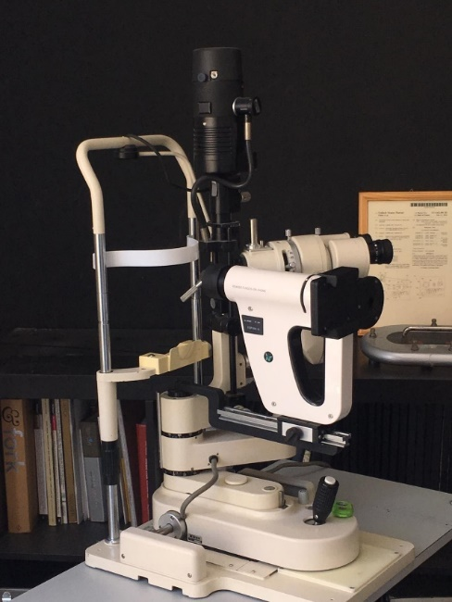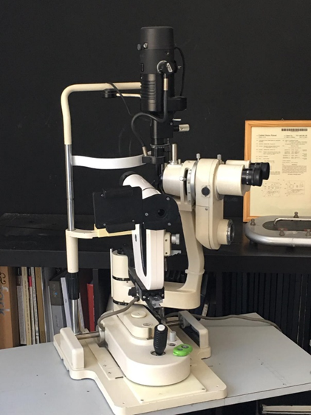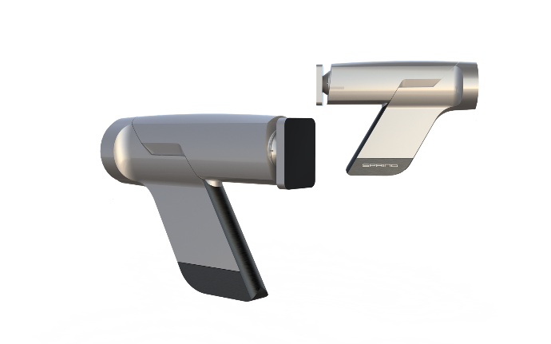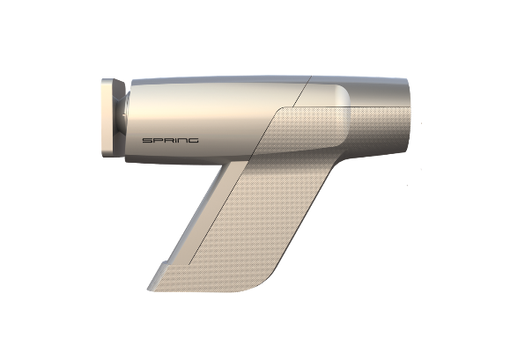
- Communications:
  - Wi-Fi - IEEE 802.11ac
  - Wired Ethernet connection 500Mb and Higher
  - Bluetooth - within device components for triggering
  - Settings/Properties can be accessed via web service

- Image Capture:
  - Non-Mydriatic mode – NIR illumination based on Auto-Illumination and Auto-Focus
    - In large FOV Mydriatic mode using white illumination based on Auto-Illumination and Auto-Focus
  - First Image captured - Color (white light 400-700 nm image) – Auto-Exposure based on Auto-illumination and Auto-Focus data, when possible
  - Second Image - Multi-Spectral Angiography image
  - Third Image – Semi-Fluorescence and/or FAF image
  - Fourth image - Multi-Spectral Oximetry image

- Image Display:
  - Live (NIR) image whenever needed – on 3.5” monitor
  - Color Image immediately after capture – on 10” tablet
  - Multi- Spectral (when applicable) – on 10” tablet - processed image (raw data and finer data as developed by image processing / AI)

- Imaging:
  - Standard FOV (45 degrees) in Non-mydriatic mode (pupils larger than 3.0mm).
  - Optical and Camera Should resolve 2micron resolution at Retina in both Standard FOV and Large FOV
  - Spectral Imaging:
    - A-Mode :2-10mSec pulse, 0.5-1W, 3 parallel light sources: 412Nm (+-10-15Nm), 550Nm (+-20Nm), and 670Nm (+-30Nm)
    - Semi-Fluorescence & FAF image: 5-10 mSec, 1-3W, 365Nm (+-15Nm)
    - O-mode: 2-10mSec pulse, 0.5-1W, 3 parallel light sources: 470Nm (+-10-15Nm), 550Nm (+-20Nm), and 670Nm (+-30-40Nm)

- Regulatory: the product has to meet ISO 10940, 15004-2 standard being validated at prototype level

Remidio – SBV Development Agreement
NRE work order for SPRING slit-lamp add-on system
- Sensor & camera selection: Sony IMX178, low noise high spectral sensitivity and QE in Blue (400nm), 12 bit, 25-30 Frames/sec
- Preferable global shutter (or rolling shutter with global reset),
- Raw (12bit data) from RGB sensor (totally unprocessed mode for multi Spectral images)
- without IR and UV cut filters
- disabling option of all automatic operations (AGC, WB, BLC etc.),
- hardware HDR (can be disabled manually)
- Image format: raw (as BMP, TIFF, PNG) or processed (JPEG))
- Providing adequate image magnification to support sensor
  - Currently, Matrix Vision BF3-3M board-level camera was selected and delivered to SBV R&D during May 2019
  - SBV to check an alternative source of BLC based on same CMOS sensor during June-August 2019

- Specific additional LEDs in light source: adding to NIR continuous and White flash (2-10mSec) control of 5 additional light sources (1-3 out of 5) sources in parallel - 360, 412, 470, 550, 670Nm. Control of all 5 light sources:
- SW controlled illumination - one or more of any of the following LEDs
- Switch between combinations: 365, 412&670, 470&670, 412&550&670
- Documentation and datasheet of LEDs and filters
- Consider option of adding IR cut filter in front of the blue LEDs in order to avoid artifacts at red channel
  - Currently, Remidio and SBV agreed to use the following LEDs for initial use. LUMINUS family as specified by Remidio and reviewed by SBV: 365Nm - SST-10-UV (365Nm binning), 412Nm – SST-10-UV (405Nm Binning), 470Nm – SST-10-SB (B7 binning, 470Nm max peak), 550Nm – SST-10-G (G7 binning, 540Nm max peak), 670Nm SST-10-DR (D6 binning, 670Nm max peak)
  - Remidio commits to supply first unit by July 18^{t}, 2019 with clinical test to be performed locally in Bangalore same week.
  - Additional LEDs as ordered from LUMINUS are expected to be delivered by July 15th. Remidio will ship second unit with alternative LED combination rings by July 31st (but not later than 3 weeks from delivery from Luminus) with Control API for SBV to integrate in the unit
  - Third unit -SBV intends to receive by August 30th, a LED ring that includes all light sources (NIR, white, and all 5 wavelengths as specified at 2.1) based on LUMINUS integration into single solid-state LED source at illumination unit (eliminating a temporary need to replace LED rings for each mode). Remidio will ship third unit not later than 3 weeks from delivery from Luminus, with the combined illumination and cotrol.
  - By September 30th, all 3 units will be upgraded to include 2.4 improvements

- Proprietary control board & API
  - Linux based API for image acquisition, V4L2 driver (if possible)
  - memory for 100 images for communication breakdown cases
  - API for external device (iPad or Android Tablet, Windows)
  - API including:
    - Control of all camera settings
    - LED (type, mW, time)
    - Focus mechanisms (gross and fine movements)
    - Communication: Wi-Fi, Bluetooth, USB3.0 or USB-C, ethernet
    - API in C++ with Python wrapper
    - Detailed API in appendix B

- Motorized focus control of gross and fine focus mechanism – with API

- Regulatory – the product with undergo the required regulatory process by Remidio qualified lab in Bangalore, India. Units to be validated for ISO 10940, 15004-2 at a certified lab. SBV personnel will attend the process.

- Required Deliverables
  - July 18, 2019: First Unit - 45 degrees Optics, Camera, Motorized Focus, Control board, API for all functions, standard Non-Mydriatic illumination as a first unit SBV SW development. API to agreed by July 1st, 2019.
  - July 31, 2019: Second unit- In addition to First Unit specifications - LED rings as specified at 2.3 above.
  - August 30, 2019: Third unit - Single LED ring with full functionalities as specified at 2.4 above.
  - September 30, 2019 - Upgrade of first and second unit to latest version. Units to be validated for ISO 10940, 15004-2 at a certified lab.

- Payments
  - SBV paid US$1995 for camera integration and US$970 for Single-Board camera deliveries –during May and June 2019 altogether US$2,965
  - July 9, 2019 - Interim down payment of US$13,000
  - First unit delivery payment of $US12,500
  - Second unit delivery payment of US$10,000
  - –Third unit delivery payment $13,500
  - September 30th, 2019 – final delivery of 3 45degrees units to meet regulatory requirements – payment $6,000 plus additional payment to cover direct cost of lab and work-time of Remidio personnel to prepare.
  - November 15th, 2019 - Delivery of additional 7 units - transfer price TBD, based on OEM pricing for small number of units

- IP ownership and deliverables
  - Definitions:
    - “Deliverables” means all know how, Inventions, documentation and other materials produced as a result of the services provided hereunder (the "Services") whether developed or conceived by Remidio prior to the date hereof or thereafter, including but not limited to modifications to its NM-FOP45 design to meet specification for 45 degrees NM optics (with 3 mm mm pupil).
    - “Remidio Background IP” means Intellectual Property of Remidio that has been conceived by Remidio, or licensed to the Remidio by any third party, prior to or independent of the Services.
    - "SBV Background IP" means Intellectual Property of SBV that has been conceived by SBV, or licensed to SBV by any third party, including but not limited to, patents GB2487940 and provisional patents US62/724,116, US62/816,343 and US62/864,191 attached to this document and other knowhow partly documented in this specification file.
    - “Invention” means any idea, design, concept, technique, invention, discovery, or improvement, regardless of patentability, made solely or jointly by Remidio, produced by or for Remidio, or made jointly by Remidio with one or more employees of SBV, during the term of this in the course of performance of the Services, excluding any Remidio Background IP.

  - Title to all Deliverables and Inventions and all Intellectual Property rights and interest attached/connected/related thereto, excluding any Remidio Background IP ("Proprietary Materials") will vest in SBV and the SBV shall be the full and sole owner of all Proprietary Materials. Remidio and its employees and contractors shall execute all such assignments, oaths, declarations and other documents as may be necessary to effect the foregoing. All works in progress, including schematics, layout and documents shall be considered the property of the SVB and shall be provided to the SVB upon the completion of the Deliverables or the termination of this Agreement.

  - Notwithstanding the provisions of Section 8.2, it is clarified that during the provision of the Services and thereafter, all Intellectual Property rights in Remidio Background IP, whether or not used in the Services and/or the Deliverables, are in the full and sole ownership of Remidio. The parties hereby acknowledge that the Remidio Background IP will be used and implemented in the Deliverables, and that its use is critical for achieving the goals set out herein. Remidio hereby grants to SBV, an irrevocable, perpetual, worldwide, non-transferable, sublicensable (including third parties, affiliates and subsidiaries of SBV), royalty free license to sell, display, distribute, market, , solely for the purpose of use of the Deliverables, and for the commercialization of the SVB's products as well as the products of third parties (the "License"). In the event that Remidio shall not meet its obligation under the terms of the OEM agreement to produce the items based on the deliverables (the “Products”) then SBV’s License shall be expanded to included also the make, use, reproduce, prepare derivative works of, commercially exploit, disclose, the Remidio Background IP for the purpose of producing the Products by a third party manufacturer chosen by SVB at its sole discretion.

  - SBV is the full and sole owner of all the SBV Background IP. SBV hereby grants to Remidio, a revocable, non-transferable, non-sublicensable (including third parties, affiliates and subsidiaries of Remidio unless approved in advance and in writing by SVB), royalty free license to use, certain SBV Background IP provided to Remidio by SBV in the course of the provision of the services, solely for the purpose of providing the Services to SVB. Remidio shall cease to use all such SVB Background IP upon the earlier of the completion of the provision of the Services or SBV's first demand and shall immediately return all copies of such to SBV.

  - Without derogating from the terms of the Non-Disclosure Agreement executed between the Parties on November 29, 2018. Each Party (the “Receiving Party”) shall refrain from using or exploiting the other Party’s (the “Disclosing Party”) Confidential Information, for any purposes or activities other than for the performance of this Agreement. Receiving Party shall: (i) keep the Confidential Information confidential using at least the same degree of care it uses to protect its own confidential information, which shall in any event not be less than a reasonable degree of care; and (ii) refrain from disclosing or facilitating disclosure of Confidential Information to anyone, without Disclosing Party’s prior written consent, except its employees and consultants with a need to know such information for the purposes of the performance of this Agreement, and will advise those of its employees and consultants to whom the Confidential Information is disclosed of their obligations under this Agreement with respect to the Confidential Information. Receiving Party shall obtain and maintain in effect written confidentiality agreements similar in scope to the provisions of this section with each of its employees and/or consultants who participate in any of the work being performed under this Agreement. If Receiving Party is required by an order of a court, administrative agency, or other government body, to disclose Confidential Information, the Receiving Party shall provide the Disclosing Party with prompt notice of such order to enable the Disclosing Party to seek a protective order or otherwise prevent or restrict such disclosure, and the Receiving Party shall reasonably cooperate with the Disclosing Party in its efforts to obtain such protective order at the sole cost and expense of the Disclosing Party and make reasonable efforts to limit such disclosure and to furnish only that portion of the Confidential Information which is legally required. The obligations of confidentiality under this Agreement shall survive the termination of this Agreement. It is hereby clarified that, notwithstanding the generality of the foregoing, the Proprietary Materials, all patent and patent application data provided by SBV (some of which is still in the “black period” of provisional patent application) and any product design for versions of the product provided by SVB shall be considered the Confidential Information of the SBV.

For SPRING BIOMED VISION LTD. For REMIDIO INNOVATIVE SOLUTIONS PVT LTD.
Signature: _____________________ Signature: __________________________
Name and Title: ________________ Name and Title: _____________________
Date: _______________________ Date: ____________________________

Appendix A - Patents
Patent Attachments – Remidio

Patent Attachments – SPRING Biomed Vision
Granted
GB 2487940 Methods and Devices suitable for imaging blood-containing tissue
Provisional
US 62/724,116 - OXYGENATED-BLOOD CONTENT OF BIOLOGICAL TISSUE
US 62/816,343 - SYSTEM AND METHOD FOR RETINAL AND BIOLOGICAL TISSUES IMAGE CONTRAST ENHANCEMENT
US 62/864,191 - SYSTEM AND METHOD FOR FLUORECENTIC IMAGING OF RETINAL AND BIOLOGICAL TISSUE

Appendix B – API details
